2026 Church of Christ at Bouldercrest Curriculum: “ABIDE”
Base Scripture: John 15:1-6
Theme Focus: Remaining rooted in Christ to bear lasting fruit.
January 2026: “Rooted in Relationship”
Focus: Establishing a deep, personal connection with Christ.
 All Adult Lesson Series
Week | Scripture | Main Point | Sub-Points
1 | John 15:1–2 | Christ is our source | (1)We must remain connected to Him;  (2) Fruitfulness flows from intimacy
2 | Psalm 1:1–3 | Rooted in God’s Word | (1) Meditation leads to stability;  (2) God's Word nourishes growth
3 | Colossians 2:6–7 | Walk in Him | - Spiritual maturity begins with rootedness;  - Faith is strengthened through connection
4 | Jeremiah 17:7–8 | Trusting the Source | - Trust brings resilience;  - God sustains in drought seasons
This Month's Event: “Rooted Retreat”
- Audience: All Adult Classes
- Activities: Devotional stations, prayer walks, journaling workshops
- Volunteers Needed: growth group leaders, resource team, adult activity coordinators
 Resources
- “Abiding in Christ” by Andrew Murray (Adult study)
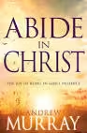
 Assessment
- Adults: Reflection worksheet on spiritual habits
 Spiritual Gifts Focus
- Worship: Personal devotion and praise
- Grow: Bible study and prayer journaling
- Serve: Encouraging others through testimony
February 2026: “Pruned for Purpose”
Focus: Embracing spiritual refinement and growth.
Adult Lesson Series
Week | Scripture | Main Point | Sub-Points
1 | John 15:3-4 | God prunes to grow | - Pruning removes hindrances;  - Growth follows surrender
2 | Hebrews 12:5–11 | Discipline is love | - Correction is for our good;  - It yields righteousness
3 | James 1:2–4 | Trials produce maturity | - Endurance builds character;  - Faith is refined through testing
4 | Romans 8:28–29 | Purpose in pain | - God works all things for good;  - We are shaped into Christ’s image
 This Month's Event: “Growth Garden Day”
- Audience: Families
- Activities: Planting garden beds, spiritual growth stations
- Volunteers Needed: Garden setup team, youth mentors, devotional facilitators
Resources
- “Spiritual Disciplines Handbook” by Adele Calhoun
- 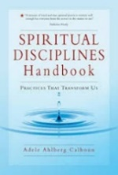
Assessment
- Adults: Spiritual discipline tracker
- 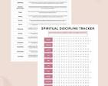
Spiritual Gifts Focus
- Worship: Communion and renewal
- Grow: Embracing spiritual disciplines
- Serve: Helping others through encouragement and accountability
March 2026: “Fruitful Living”
Focus: Living out the visible results of abiding in Christ. John 15:5-6
Adult Lesson Series
Week | Scripture | Main Point | Sub-Points
1 | Galatians 5:22–23 | Fruit of the Spirit | (1) Love is the root;  (2) Fruit reflects character
2 | Matthew 5:14–16 | Shine your light | - Good works glorify God;  - Fruit blesses others
3 | John 13:34–35 | Love as evidence | - Love proves discipleship;  - It builds community
4 | Philippians 1:9–11 | Abounding in fruit | - Knowledge and discernment lead to fruitfulness;  - Fruit glorifies God
This Month's Event: “Fruit Festival”
- Audience: Community outreach
- Activities: Service projects, fruit-themed games, testimonies
- Volunteers Needed: Outreach team, event planners, youth leaders
Resources
- “Cultivating the Fruit of the Spirit” by Christopher J.H. Wright
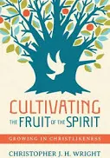
Assessment
- Adults: Fruitfulness self-evaluation
- 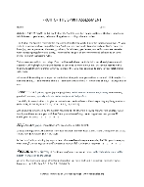
Spiritual Gifts Focus
- Worship: Living a life of praise
- Grow: Bearing spiritual fruit
- Serve: Acts of service and evangelism

